Question Bank
Preparation for final examination
International Economics
- David Ricardo developed the theory of comparative advantage. Use this theory to answer the following
a) What is absolute advantage and what is comparative advantage.
b) Why would a country import an item from another country that was less efficient at producing that item? Trade is guided by comparative advantage, not absolute advantage or efficiency.
c) Why is trade beneficial to both countries? Trade allows a country to move outside itsown production possibilities curve. Depending on the relative prices of its imports and exports, it may become much better off than if it was self-sufficient.
- Describe how the share of international production that is traded has fluctuated over time and why there have been two ages of globalization.
- Write a short note on:
- Comparative advantage
- Gravity model of international trade

- Define International Trade.
- State the concept of static gains from trade.
- Explain the Ricardian theory of Comparative Cost.
- Describe how the value of trade between any two countries depends on the size of these countries’ economies and explain the reasons for that relationship.
- Discuss how distance and borders reduce trade.
- Explain how the mix of goods and services that are traded internationally has changed over time.
- Define International Trade
- What is free trade?
- What is Opportunity cost concept in Ricardian Theory?
- State the concept of 'Absolute Cost Advantage'.
- State the nature and scope and importance of International Economics
- Trade as an engine of economic growth. Discuss
- In the discussion of empirical results on the Heckscher-Ohlin model, we noted that recent work suggests that the efficiency of factors of production seems to differ internationally. Explain how this would affect the concept of factor-price equalization.
- What is factor of endowment theory of international trade?
- What are the assumption of H. O Model? Explain three assumptions.

- For each of the following examples, explain whether it is a case of external or internal economies of scale:
- Most musical wind instruments in the United States are produced by more than a dozen factories in Elkhart, Indiana.
- All Hondas sold in the United States are either imported or produced in Marysville, Ohio.
- All airframes for Airbus, Europe’s only producer of large aircraft, are assembled in Toulouse, France.
- Hartford, Connecticut, is the insurance capital of the northeastern United States.
- Define Labor pooling and Knowledge spillovers?
- What will happen when the countries open up the potential for trade in buttons?
- What might cause one country to have an initial advantage from having a lower price?
- How do you interpret the following curve?
- What is the difference between External economies of scale and Internal economies of scale?
- What do we mean by increasing returns to scale or economies of scale?
- What is the impact of economic geography on international trade?
- Why is it that if an industry is operating under conditions of internal scale economies then the resultant equilibrium cannot be consistent with the pure competition model?

Countries | Ton of Textiles | Books
UK | 80 | 40
India | 20 | 20
Use the information in the table below to answer the next five questions.

- The opportunity cost of one books in India is:

a. One ton of Textiles b. Two tons of Textiles
c. Three tons of Textiles d. Four tons of Textiles
- The opportunity cost of one books in UK is:
a. One-half ton of Textiles b. One ton of Textiles
c. One and one-half tons of Textiles d. Two tons of Textiles

- According to the principle of absolute advantage; India should:

a. Export Textiles b. Export books
c. Export Textiles and books d. There is no basis for gainful
specialization and trade
- According to the principle of comparative advantage:
a. UK should export Textiles b. UK should export Textiles and books
c. India should export Textiles d. India should export Textiles and books
- With international trade, what would be the maximum number of books that India would be willing to export to UK in exchange for each ton of Textiles:
a. One books b. Two books
c. Three books d. Four books

Use the information in the table below to answer the next six questions. (20 Points - 5 Points each)
Country | Tons of Cotton | Mobile
USA | 70 | 30
China | 20 | 25

- The opportunity cost of one Mobile in China is:

a. One ton of Cotton b. Two tons of Cotton
c. Three tons of Cotton d. Four tons of Cotton
- The opportunity cost of one Mobile in USA is:

a. One-half ton of Cotton b. One ton of Cotton
c. One and one-half tons of Cotton d. Two tons of Cotton

- According to the principle of absolute advantage; China should:

a. Export Cotton b. Export Mobile
c. Export Cotton and Mobile d. There is no basis for
gainful specialization and
trade
- According to the principle of comparative advantage:
a. USA should export Cotton b. USA should export
Cotton and Mobile
c. China should export Cotton d. China should export
Cotton and Mobile

- With international trade, what would be the maximum number of Mobile that China would be willing to export to USA in exchange for each ton of Cotton:

a. One Mobile b. Two Mobile
c. Three Mobile d. Four Mobile
Use the information in the table below to answer the next six questions.
Country | Tons of steel | DVDs
South Korea | 80 | 40
Japan | 20 | 20

- The opportunity cost of one DVD in Japan is:
a. One ton of steel b. Two tons of steel
c. Three tons of steel d. Four tons of steel
- The opportunity cost of one DVD in South Korea is:
a. One-half ton of steel b. One ton of steel
c. One and one-half tons of steel d. Two tons of steel

- According to the principle of absolute advantage; Japan should:

a. Export steel b. Export DVDs
c. Export steel and DVDs d. There is no basis for
gainful specialization and
trade
- According to the principle of comparative advantage:

a. South Korea should export steel b. South Korea should export
steel and DVDs
c. Japan should export steel d. Japan should export steel
and DVDs
- With international trade, what would be the maximum number of DVDs that Japan would be willing to export to South Korea in exchange for each ton of steel:

a. One DVD b. Two DVDs
c. Three DVDs d. Four DVDs
- Use the information in the table below to answer the next six questions.
Country | Tons of Wool | Mobile
America | 79 | 39
China | 19 | 19

- The opportunity cost of one mobile in China is:
a. One ton of Wool ( ) b. Two tons of Wool ( )
c. Three tons of Wool ( ) d. Four tons of Wool ( )
- The opportunity cost of one mobile in America is:
a. One-half ton of Wool ( ) b. One ton of Wool ( )
c. One and one-half tons of Wool ( ) d. Two tons of Wool ( )

- According to the principle of absolute advantage; China should:
a. Export Wool ( ) b. Export Mobile ( )
c. Export Wool and Mobile ( ) d. There is no basis for ( )
gainful specialization and
trade
- According to the principle of comparative advantage: a. America should export Wool ( ) b. America should export ( ) Wool and Mobile
c. China should export Wool ( ) d. China should export Wool ( ) and Mobile

- With international trade, what would be the maximum number of Mobile that China would be willing to export to America in exchange for each ton of Wool:
a. One Mobile ( ) b. Two Mobile ( )
c. Three Mobile ( ) d. Four Mobile ( )

Multiple choice questions
- Concept that occurs when some activity is being performed outside of a firm but within an industry is known to be as
- economies of scale
- internal economies of scale
- external economies of scale
- diseconomies of scale

- Ricardo’s Law of Comparative advantage is based on
  - Labour theory of value
  - Opportunity cost
  - Law of diminishing returns
  - All the above
3) The terms of trade of developing countries have a secular tendency to
  - Improve
  - Deteriorate
  - first improve and then deteriorate
  - Remain the same

- The opportunity cost theory assumes that
  - Labour is the only factor of production
  - The price or the cost of a commodity can be determined by the labour content in it
  - Labour is homogeneous
  - None of the above

- Theory of Absolute advantage is
  - A rejoinder of merchantalism
  - A corollary of merchantalism
  - Critique of merchantalism
  - None of the above

- Adam Smith identified the basic reason for trade between two nations as
  - The difference in Absolute advantage
  - The difference in comparative advantage
  - Difference in factor endowments
  - None of the above.

- Before the First World War, Germany promoted a trade expansion policy through far-reaching operations in:

- India;
- Argentina;
- Brazil;
- Congo;
- African countries

- The gravity model offers a logical explanation for the fact that

- Trade between Asia and the U.S. has grown faster than NAFTA trade.
- Trade in services has grown faster than trade in goods.
- Trade in manufactures has grown faster than in agricultural products.
- Intra-European Union trade exceeds international trade by the European Union.
- The U.S. trades more with Western Europe than it does with Canada.

- A foreign direct investment actor is represented by:

  - the government;
  - transnational private enterprises;
  - subsidiaries of transnational companies;
  - IMF;
  - The World Bank.

- The basis for the international growth of companies lies in:

- prior knowledge of the international market most often obtained by import;
- lack of available resources to finance this growth;
- the existence of real or potential outlets in several countries, these being the growth reserve of the company;
- decreased productivity;
- the desire to conquer new markets.

- Approximately what percent of all world production of goods and services is exported to other countries?

- 10%
- 30%
- 50%
- 100%
- 90%
- The terms of trade of developing countries have a secular tendency to
  - Improve
  - Deteriorate
  - first improve and then deteriorate
  - Remain the same

- The opportunity cost theory assumes that
  - Labour is the only factor of production
  - The price or the cost of a commodity can be determined by the labour content in it
  - Labour is homogeneous
  - None of the above

- Adam Smith identified the basic reason for trade between two nations as
  - The difference in Absolute advantage
  - The difference in comparative advantage
  - Difference in factor endowments
  - None of the above.

- Theory of Absolute advantage is
  - A rejoinder of Merchantalism
  - A corollary of merchantalism
  - Critique of merchantalism
  - None of the above

- Recardo’s Law of Comparative advantage is based on
  - Labour theory of value
  - Opportunity cost
  - Law of diminishing returns
  - All the above
17) Which of the following is not one of the international economic institutions that were created at the end of World War II?

a. International Monetary Fund
b. International Bank for Reconstruction and Development
c. General Agreement on Tariffs and Trade
d. World Trade Organization
e. World Bank

- During the half century since the end of World War II.

- The major currencies of the world, which initially had flexible exchange rates, have become fixed.
- The World Bank has switched from providing assistance to poor countries to primarily settling transactions among rich countries.
- The GATT has been transformed into the WTO.
- The IMF has changed from being a members-only bank to being a mutual fund for investment in emerging-economy stock markets.
- Tariffs levied by developed countries against developing-country exports have increased.

- Which of the following was the name of one of the GATT negotiating rounds?
a. NAFTA
b. Wilbur
c. Nixon
d. Seattle
e. Uruguay
- How many countries are member of the G-20?
a. 7
b. 8
c. 19
d. 20
e. 24

- What, according to the assigned article by Donnan about the December 2013 WTO
Ministerial Meeting, is meant by “trade facilitation”?
a. Export subsidies
b. Import subsidies
c. A package to help businesses get their products through borders more easily
d. Reform of export credit facilities
e. Expansion of national export-import banks
- Which of the following countries is not currently negotiating to be part of the Trans-
Pacific Partnership?

a. Brunei
b. United States
c. Chile
d. China
e. Malaysia
- Given below is a table showing the maximum amount of wheat and cloth that the UK and U S could produce if they fully utilize all the factors of production with the best technology available indicate the comparative advantage of U K and U S.

- US have comparative advantage in cloth and U K have comparative advantage in wheat.
- U K have comparative advantage in cloth and US have comparative advantage in wheat.
- US have comparative advantage in cloth and wheat.
- UK have comparative advantage in cloth wheat.
- Indicate, by circling the correct answer,
What the Heckscher-Ohlin model predicts about the changes that will occur when a country opens up to international trade.
- Production of its export good will:
expand ( ) contract ( ) stay the same ( )
Ans: expand
- Production of its import-competing good will:
expand ( ) contract ( ) stay the same ( )
Ans: contract
- Demand for the country’s abundant factor (at initial factor prices) will
increase ( ) decrease ( ) stay the same ( )
Ans: increase
- The price of the scarce factor will
rise ( )fall ( ) stay the same ( )
Ans: fall
- The price of the abundant factor will
Rise ( ) Fall ( ) Stay ( ) The same ( )
Ans: rise
Answer the following questions
Q01. What is International Trade?
Q02. What free trade?
Q03. What are the benefits of trade?
Q04. How international trade play a role in the development of country.
Q05. What is factor endowment theory?
Q06. What are the assumptions of H.O. Model?
Q07. How absolute advantage is different from comparative advantage?
Q08. What is gravity model?
Q09. Describe how the value of trade between any two countries depends on the size of
these countries’ economies and explain the reasons for that relationship?
Q10. Discuss how distance and borders reduce trade.
Q11. What is service outsourcing.
Q12. What are the Barriers of trade?
Q13. What is absolute advantage?
Q14. What is comparative advantage?
Q15. What is opportunity cost?
Q16. US can produce 20 Plane or 2 Cruise ship
France can produce 12 planes or 2 cruise ship.
US | 20 | 2
France | 12 | 2
QA. What is the opportunity cost for producing one of each product?
QB. Who has comparative advantage of plane?
QC. Who has comparative advantage of cruise ships.
QD. What is a terms of trade that benefits both countries?
a. 1 cruise ship for _________________Planes.

Q17. Factors of production are completely mobile within the nation but internationally mobility does not exist. Explain
Q18. Please explain the graph.

Q19. What is economies of scale?
Q20. Give two examples of products that are traded on international markets for whichthere are dynamic increasing returns. In each of your examples, show how innovationand learning-by-doing are important to the dynamic increasing returns in the industry.
Q21. Write a short note related to economies of scale
- Intensive Labour
- Knowledge spill over
- Transportations economies

Q22. What is relation of Out and total labour output and average labour input. Explain
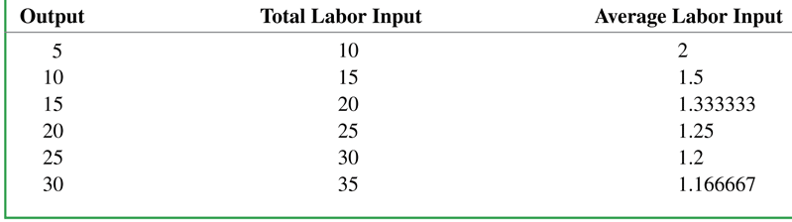
Q23. Which of the following goods or services would be most likely to be subject to
(1) externaleconomies of scale and (2) dynamic increasing returns? Explain your answers.

a. Software tech-support services
b. Production of asphalt or concrete
c. Motion pictures
d. Cancer research
e. Timber harvesting

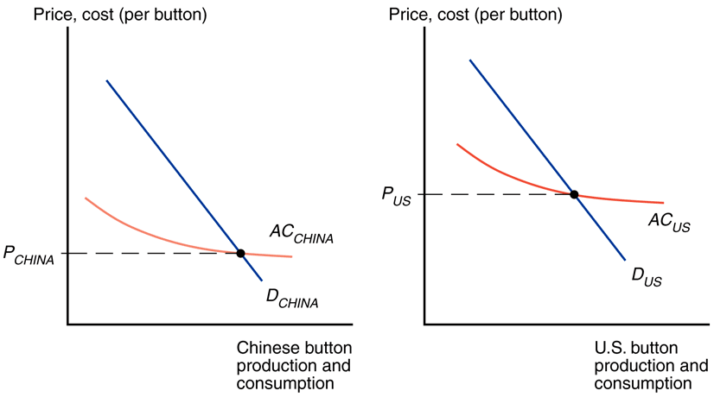
Q24. Explain the difference between the two graphs

Q25. What is internal economies of scale
Q26. What is external economies of scale.
Q27. What are reasons of existence of external economies of scale..

