Introduction to Paragraph

What is a Paragraph?
A paragraph is a series of related sentences developing a Central idea, called the Topic. Any Paragraph should have thematic Unity: a paragraph is a sentence or a group of sentences that supports one central, unified idea. Paragraphs add one idea at a time to your broader argument.

How do I unify my ideas in a paragraph?
Probably the most effective way to achieve paragraph unity is to express the central idea of the paragraph in a topic sentence.

Topic sentences are similar to mini thesis statements. Like a thesis statement, a topic sentence has a specific main point. Whereas the thesis is the main point of the essay, the topic sentence is the main point of the paragraph. Like the thesis statement, a topic sentence has a unifying function. But a thesis statement or topic sentence alone doesn’t guarantee unity. An essay is unified if all the paragraphs relate to the thesis, whereas a paragraph is unified if all the sentences relate to the topic sentence. Note: Not all paragraphs need topic sentences. In particular, opening and closing paragraphs, which serve different functions from body paragraphs, generally don’t have topic sentences.

In academic writing, the topic sentence nearly always works best at the beginning of a paragraph so that the reader knows what to expect:

The embrace of Twitter by politicians and journalists has been one of its most notable features in recent years: for both groups the use of Twitter is becoming close to a requirement.

—Paul Bernal, “A Defence of Responsible Tweeting”

This topic sentence forecasts the central idea or main point of the paragraph: “politicians” and “journalists” rely on Twitter. The rest of the paragraph will focus on these two Twitter-user groups, thereby fulfilling the promise made by the topic sentence. By avoiding irrelevant information that does not relate to the topic sentence, you can compose a unified paragraph.

How do I develop my ideas in a paragraph?
Often, the body paragraph demonstrates and develops your topic sentence through an ordered, logical progression of ideas. There are a number of useful techniques for expanding on topic sentences and developing your ideas in a paragraph. Illustration in a paragraph supports a general statement by means of examples, details, or relevant quotations (with your comments).

.
The introductory paragraph is a specialty paragraph that introduces the reader to an essay. Below are two examples of well structured introductory paragraphs. They contain the three basic elements necessary for all introductory paragraphs: the topic sentence(s), which define the topic and "grab" the reader; the thesis sentence, which defines the writer's point of view regarding the topic; and the outline sentence(s), which describe the main topics in the body paragraphs.
The following are two examples of introductory paragraphs. While you certainly don't have to follow them word-for-word, these "exemplars" provide a good model to follow if you're not sure how to write your first paragraph.
In the first example, we see all three elements. As usual, the topic sentences go first, followed by the outline and thesis. The order of these elements (especially the last two parts) may vary in your own introduction.
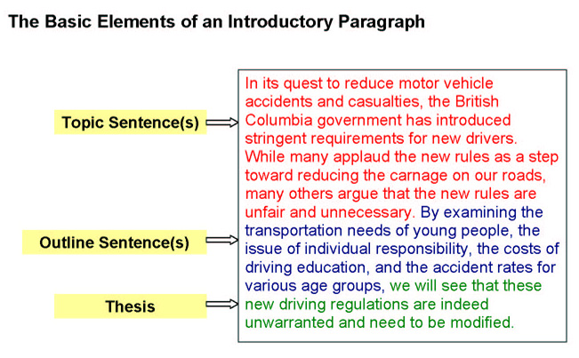

In the second example, we see a more sophisticated introductory paragraph, but all the basic introduction elements are present. The outline indicates that the body will start with an analysis of Paul Barker's position, followed by an analysis of Hiemstra and Janzen's position. These analyses will then be followed by an evaluation of both positions.
The outline often follows the thesis, so feel free to explore different structures; this example is by no means the only way to organize your introductory paragraph.

- EnglishEnglish WritingParagraph Structure
Top
Paragraph Structure

One of the main essential elements of compositions is the paragraph. Group of sentences together discussing one man topic consisting of several sentences grouped together is called a Paragraph.
A Paragraph has three primary parts which are the topic or the main subject sentence, body sentences, and the concluding or final sentence.
Paragraphs can be of changeable lengths, but must preview an intelligible argument combined under a sole topic. A Lengthy paragraph indicates lack of edifice and Short paragraphs indicate lack of substance wherein there is no enough evidence or investigation to prove a point. Effective paragraphs guide the reader by aiding to explain, validate, and support the thesis statement or the argument. An effective paragraph has three main parts: claim, evidence, and analysis.

Claim: This is a way of announcing the main focus of the paragraph; which tells the reader what the paragraph will be about. Claims are mini arguments that support the thesis, they should be uncertain claims that will try to "prove" the evidence. Each claim should be a purpose why the reader should consider the main idea. The claim contains evidence, in a realistic and interesting way by comprising specific facts, the claim is

Evidence: The evidence helps to "prove" each claim to the reader and supports or backs up claims. Evidences could include info from articles, books, files, electronic sources, or any research gathered. Evidence might take the form of a direct quotation, summarized facts, statistical data etc. It is important to represent a variety of opinions and visions. Good evidence exhibits information of the topic and includes several expert views to back up the claim.

Analysis or Concluding Statement: It is a way of "wrapping up" the evidence or facts presented in the paragraph. It explains why the evidence supports the claim and why it supports the main thesis in the paragraph. It’s important to end an analysis with individual information rather than with evidence, helping you to take control of the paper.

Structure of a Paragraph
Back to Top
A paragraph is an array of sentences prepared and related to a specific topic. The main structure of a paragraph is:
Topic sentence(s) - A paragraph consists of a main topic which is the main sentence or idea of a paragraph and tells its readers what the paragraph is going to talk about. It is usually comes at the beginning of a paragraph, it is the first sentence of introduction that clearly states the main idea that is intended to progress. A topic sentence not only is the main sentence of a paragraph, it is the most common sentence in a written paragraph. Topic sentence is a preview for the reader the kinds of info that the remaining paragraph is likely to contain. There are not many details in the sentence, but the sentence introduces an overall idea that is to be discussed later in the paragraph. Topic sentence functions as a thesis in a paragraph and further pushes the thesis of the essay and presents a debatable point.

Supporting Evidence /Analysis: Supporting the evidence is to explicate the new idea and point that has been introduced. Elaboration may include investigation, illustration and persuasion etc. While writing a paragraph a student needs to find a sense of balance between evidence provided such as proofs, evidences, quotes, summary of actions/conspiracy, etc.and analysis which includes interpretation of evidence. The supporting sentences are the additional sentences in a paragraph.These sentence either:
- Expand the main point
- Describe key terms
- Suggest explanations
- Provide examples
- Give added factors
Concluding Sentence: The last part of a paragraph is called the concluding sentence. A Concluding sentence meets the requirements of the views expressed in order to connect the present paragraph to the subsequent paragraph. It is the summary of information that has been told so far. A concluding sentence is a good idea in case the paragraph is long which connects and draws connections of all the evidence stated. It’s important that the claims you make in your conclusion are constant with the summary and body of the thesis.

