Vertical Integration and Horizontal Integration

Introduction
Vertical integration and horizontal integration are business strategies that companies use to consolidate their position among competitors.

Vertical Integration
Vertical integration is a competitive strategy by which a company takes complete control over one or more stages in the production or distribution of a product.
A company opts for vertical integration to ensure full control over the supply of the raw materials to manufacture its products. It may also employ vertical integration to take over the reins of distribution of its products.
A classic example is that of the Carnegie Steel Company, which not only bought iron mines to ensure the supply of the raw material but also took over railroads to strengthen the distribution of the final product. The strategy helped Carnegie produce cheaper steel and empowered it in the marketplace.
Horizontal Integration
Horizontal integration is another competitive strategy that companies use. An academic definition is that horizontal integration is the acquisition of business activities that are at the same level of the value chain in similar or different industries.
In simpler terms, horizontal integration is the acquisition of a related business: a fast-food restaurant chain merging with a similar business in another country to gain a foothold in foreign markets.

Vertical Integration in Strategic Management

Types of Vertical Integration Strategies
As we have seen, vertical integration integrates a company with the units supplying raw materials to it (backward integration), or with the distribution channels that carry its products to the end-consumers (forward integration).
For example, a supermarket may acquire control of farms to ensure supply of fresh vegetables (backward integration) or may buy vehicles to smoothen the distribution of its products (forward integration).
A car manufacturer may acquire tyre and electrical-component factories (backward integration) or open its own showrooms to sell its vehicle models or provide after-sales service (forward integration).
There is a third type of vertical integration, called balanced integration, which is a judicious mix of backward and forward integration strategies.
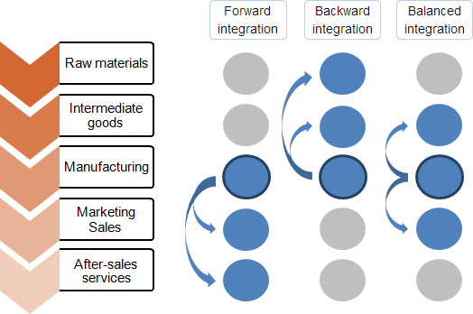
Several factors affect the decision-making that goes into backward and forward integration. A company may go in for these strategies in the following scenarios:
- The current suppliers of the company’s raw materials or components, or the distributors of its end products, are unreliable
- The prices of raw materials are unstable or the distributors charge high fees
- The suppliers or distributors earn big margins
- The company has the resources to manage the new business that is currently being taken care of by the suppliers or distributors
- The industry is expected to grow significantly

Advantages of Vertical Integration
- smoothen its supply chain (by ensuring ready supply of tyres and electrical components in the exact specifications that it requires)
- make its distribution and after-sales service more efficient (by opening its own showrooms)
- absorb for itself upstream and downstream profits (profits that would have gone to the tyre and electrical companies and showrooms owned by others)
- increase entry barriers for new entrants (by being able to reduce costs through its own suppliers and distributors)
- invest in specific functions such as tyre-making and develop its core competencies

Disadvantages of Vertical Integration
- The quality of goods supplied earlier by external sources may fall because of a lack of competition.
- Flexibility to increase or decrease production of raw materials or components may be lost as the company may need to sustain a level of production in pursuit of economies of scale.
- It may be difficult for the company to sustain core competencies as it focuses on the integration of the new units.
However, there are alternatives to vertical integration, such as purchases from the market (of tyres, for example) and short and long-term contracts (for showrooms and with service stations, for example).

Horizontal Integration in Strategic Management
Horizontal integration, as we have seen, is a company’s acquisition of a similar or a competitive business—it may acquire, but it may also merge with or takeover, another company to strengthen itself—to grow in size or capacity, to achieve economies of scale or product uniqueness, to reduce competition and risks, to increase markets, or to enter new markets.
Quick examples of horizontal expansion are Standard Oil’s acquisition of about 40 other refineries and the acquisition of Arcelor by Mittal Steel and that of Compaq by HP.
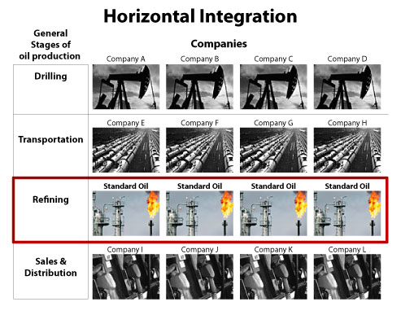
A company can think of acquisitions and mergers for horizontal integration in the following situations:
- When the industry is growing
- When rivals lack the expertise that the company has already achieved
- When economies of scale can be achieved
- When the company can manage the operations of the bigger organisation efficiently, after the integration

Advantages of Horizontal Integration
The advantages of horizontal integration are economies of scale, increased differentiation (more features that distinguish it from its competitors), increased market power and the ability to capture new markets.
- Economies of scale: The bigger, horizontally integrated company can achieve a higher production than the companies merged, at a lower cost.
- Increased differentiation: The company will be able to offer more product features to customers.
- Increased market power: The new company, because of the merger of companies, will become a bigger customer for its old suppliers. It will command a bigger end-product market and will have greater power over distributors.
- Ability to enter new markets: If the merger is with an organisation abroad, the new company will have an additional foreign market.

Disadvantages of Horizontal Integration Strategy
As touched upon earlier, the management of a company should be able to handle the bigger organisation efficiently if the advantages of horizontal integration are to be realised.
The legal ramifications will have to be studied as there are strict anti-monopoly laws in many countries: if the merged entity threatens to oust competitors from the market, these laws will be used against it.
Standard Oil, which was seen as a powerful conglomerate brooking no competition, was split up into over 30 competing companies in an anti-trust case.
As a company grows bigger with horizontal integration, it might become too rigid and its procedures and practices may become unfriendly to change. This could prove dangerous to it.
Moreover, synergies between companies that may have been predicted may prove elusive or non-existent (for example, the failed horizontal integration of hardware and software companies merged in the expectation of “synergies” between their products).
The decision whether to employ vertical or horizontal integration has a long-term influence on the business strategy of a company.
Each company will have to choose the option more suitable to it, based on its unique place in the market and its customer value propositions. A deep analysis of its strengths and resources will help it make the right choice.

